LAB 5 TASKS

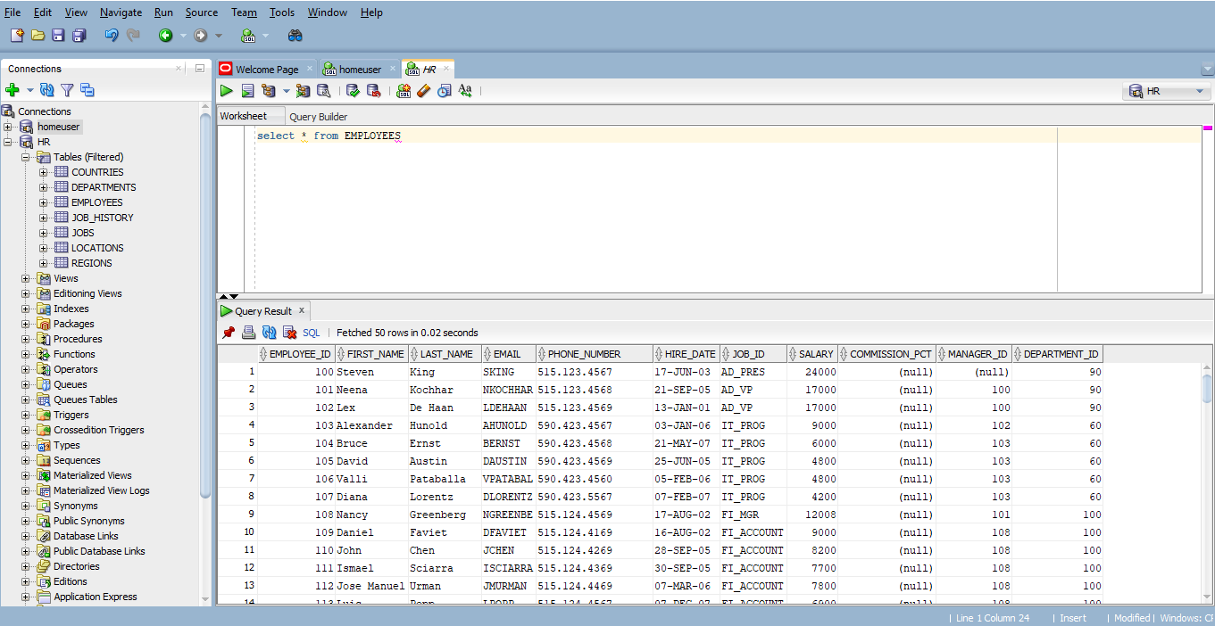
- Retrieve all data from the employees table.

- Select first_name, last_name, and email of all employees.

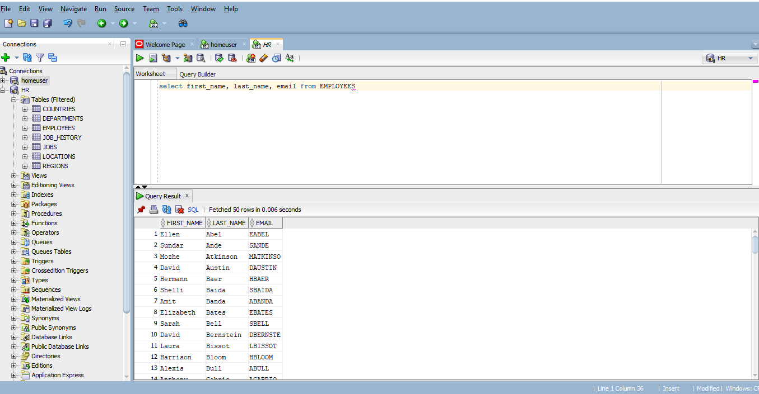

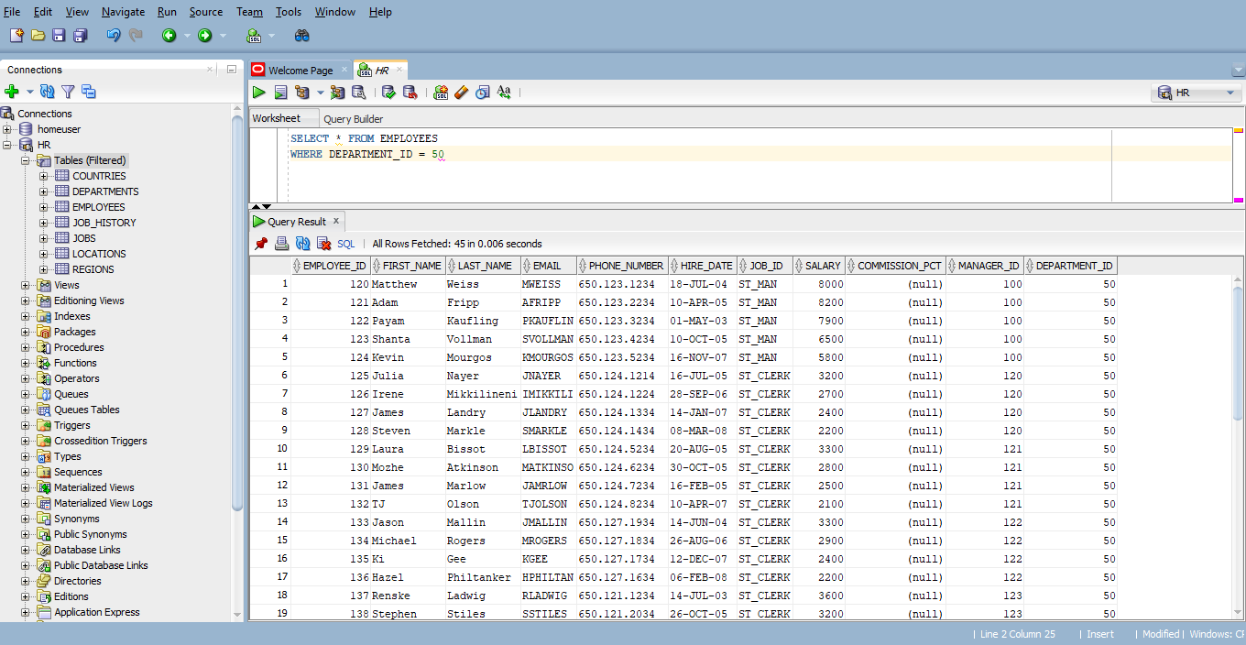
- Retrieve details of employees who work in department 50.

- Retrieve first_name and salary of employees, sorted by salary in descending order.

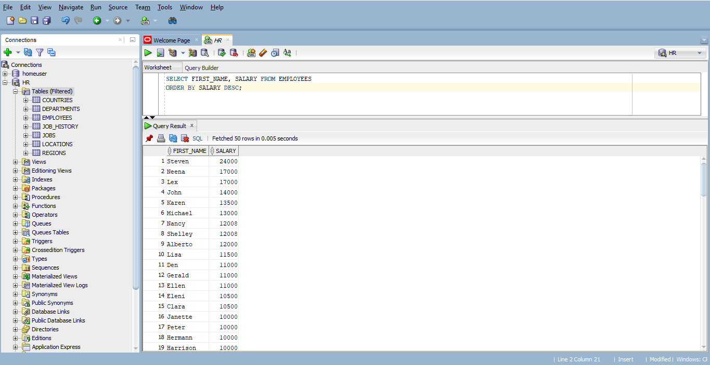

- Retrieve the first 10 employees based on their hire date.
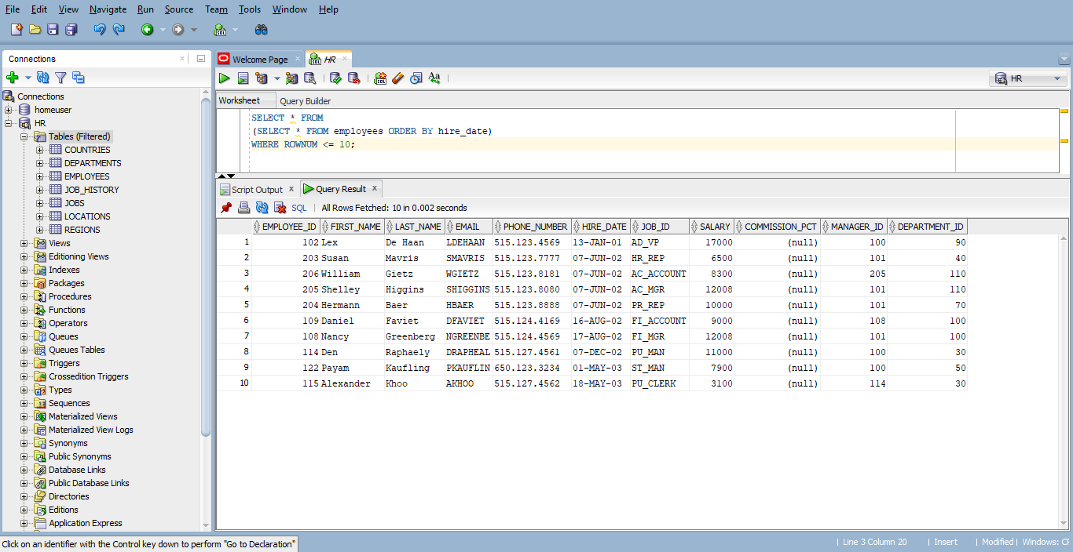

- Retrieve the names and salaries of employees whose salary is greater than 5000.
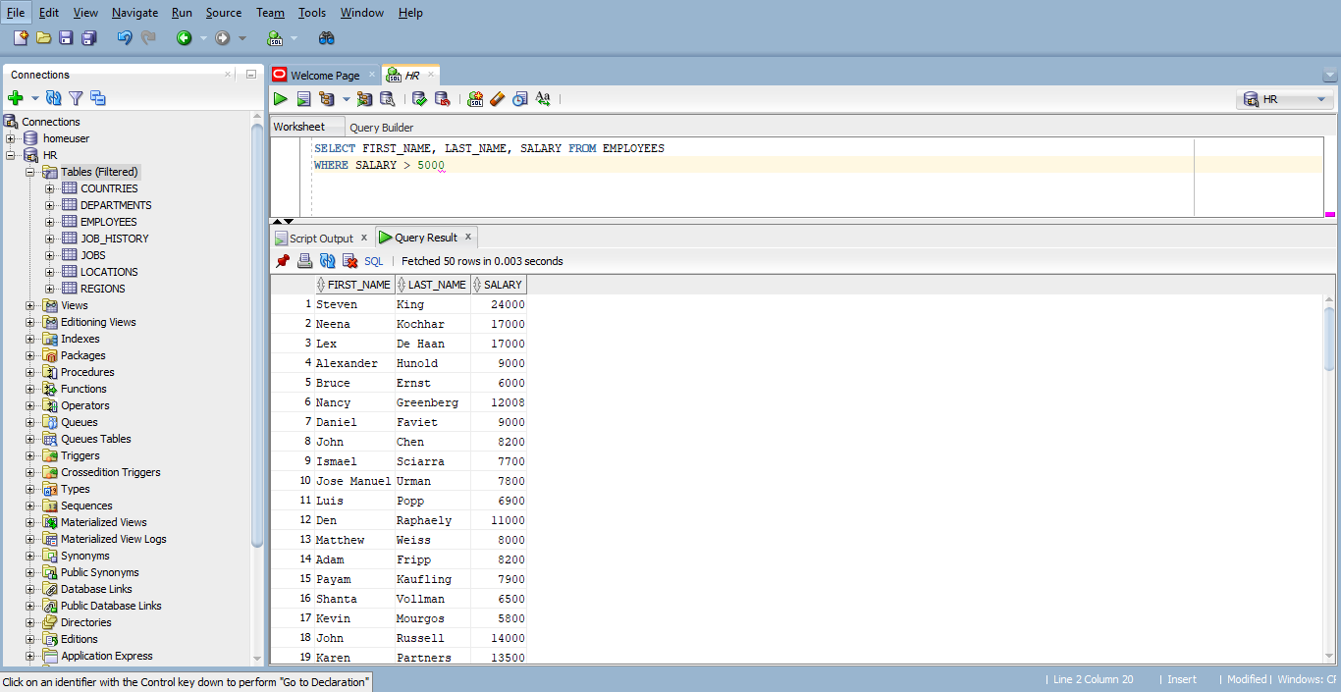

- Retrieve the names and salaries of employees whose salary is between 3000 and 7000.
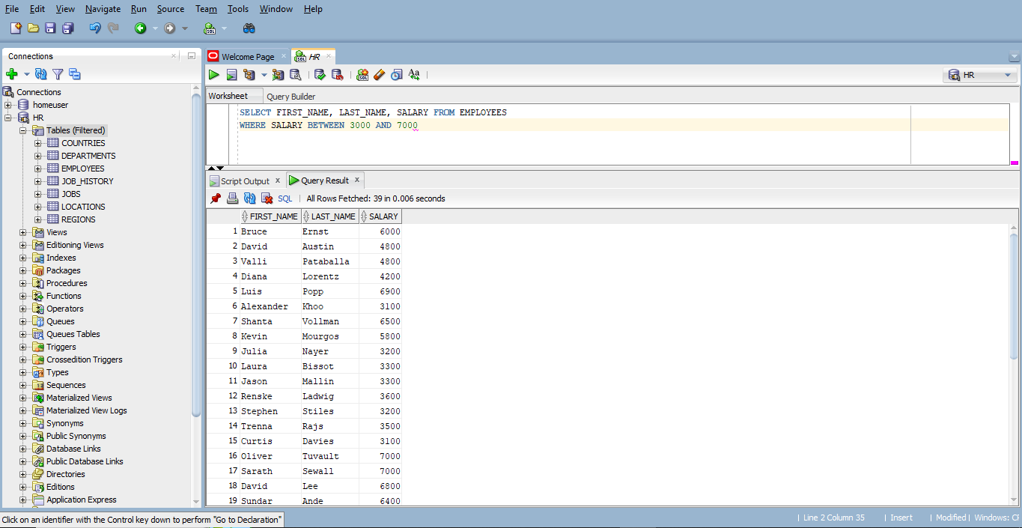

- Retrieve details of employees who work in department 10, 20, or 30.
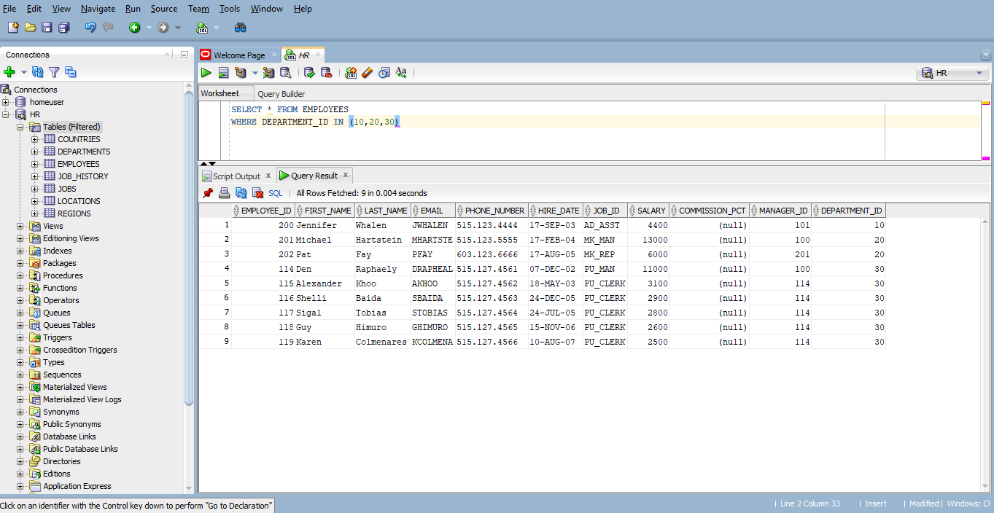

- Retrieve a list of unique department IDs from the employees table.
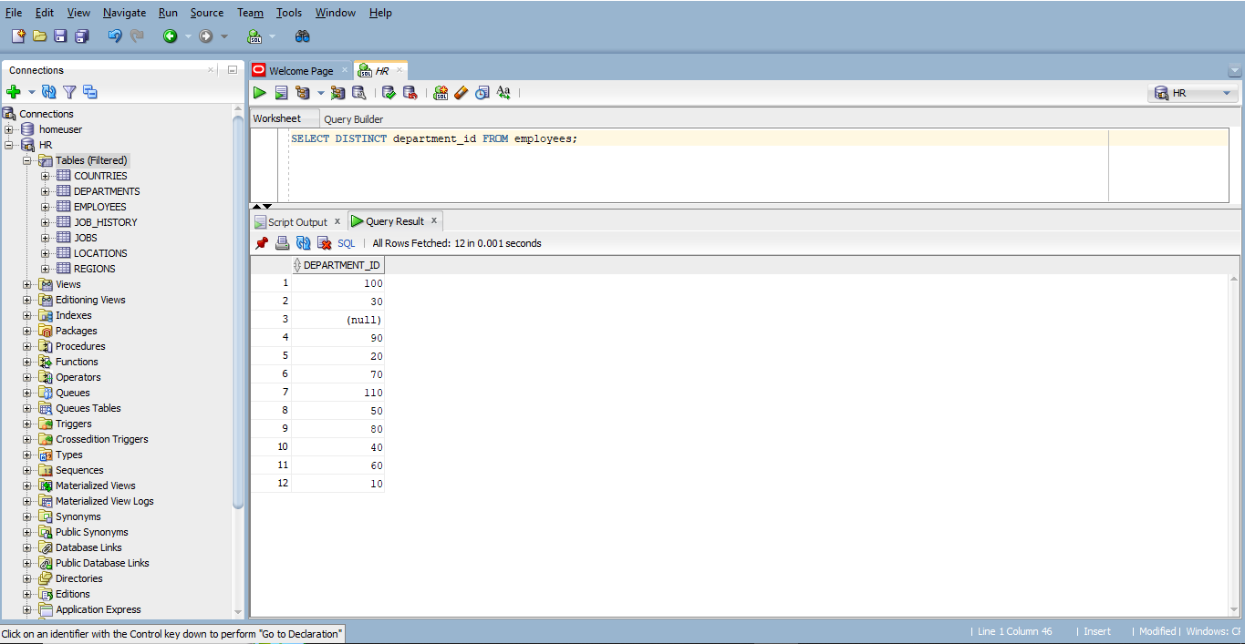

- Retrieve the first_name, last_name, and department_name of all employees by joining the employees and departments tables
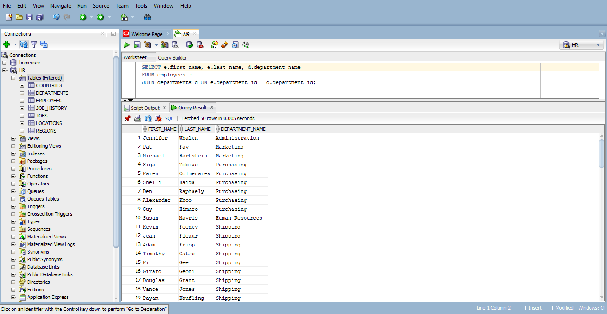

- Retrieve the first_name, last_name, and job_title of all employees by joining the employees and jobs tables.
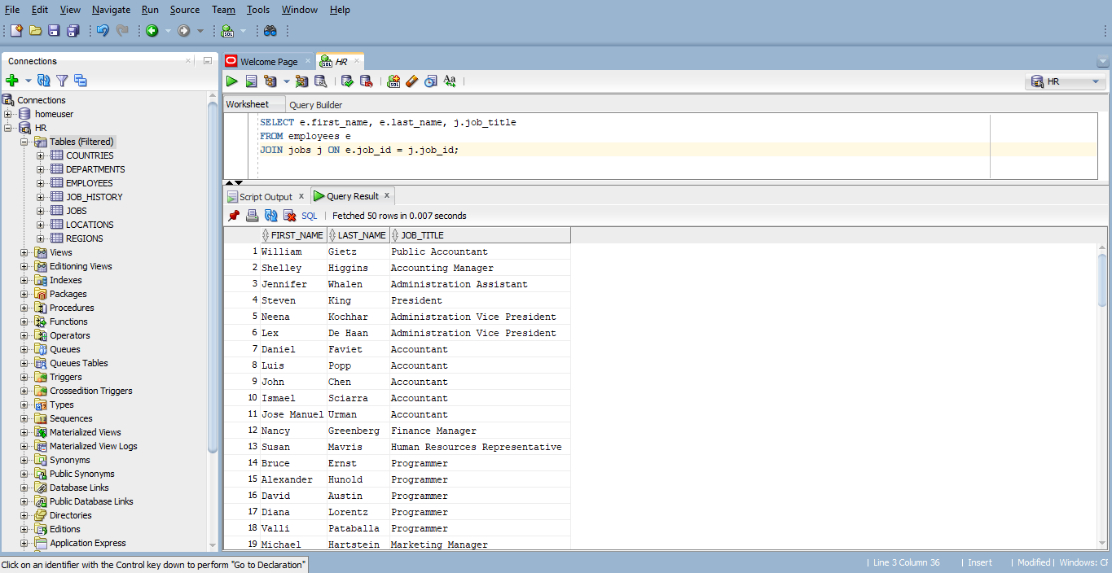

- Retrieve the first_name, last_name, department_name, and location_id of employees by joining employees, departments, and locations tables.
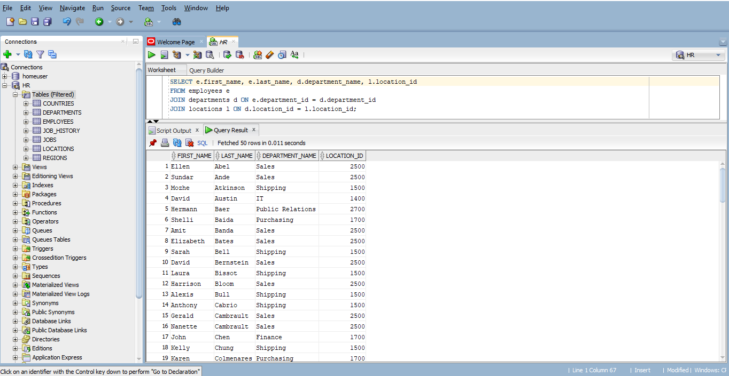

- Retrieve all employees and their department details, including those who do not belong to any department (use an outer join).
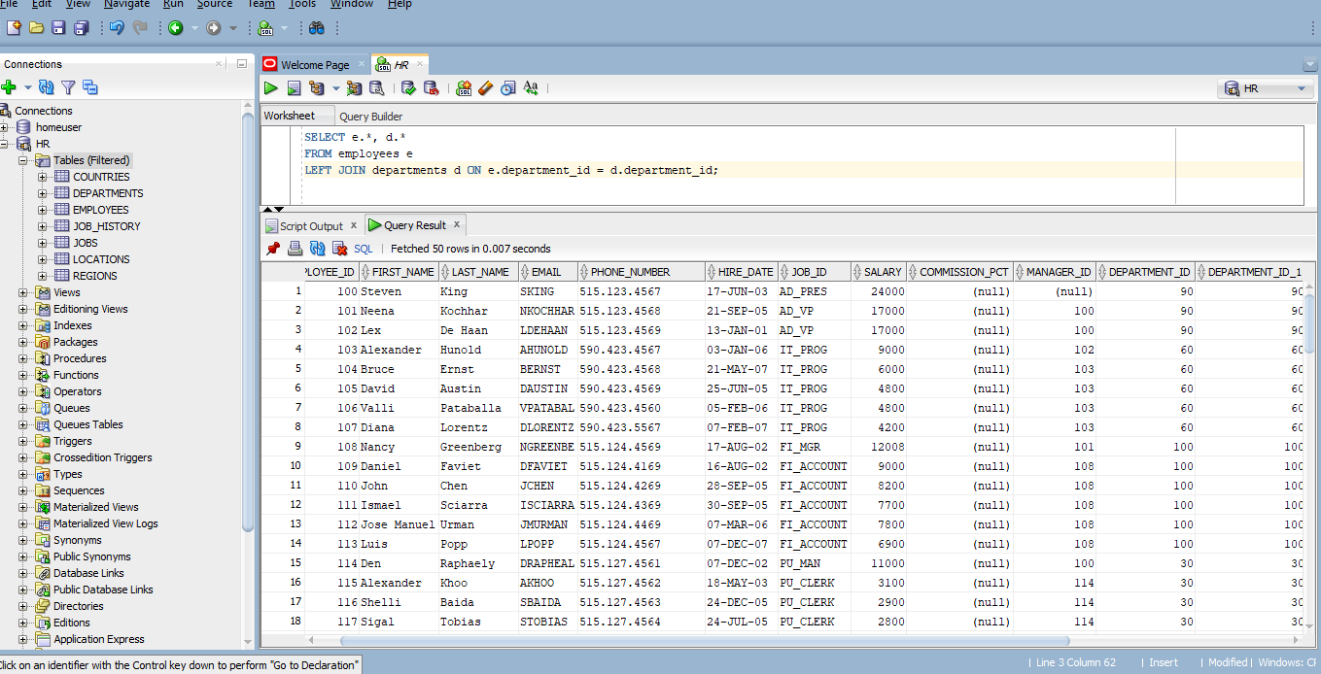

- Retrieve the first_name, last_name, and department_name of all employees, including those who are not assigned to any department, using a LEFT JOIN between the employees and departments tables( hint : use left join).
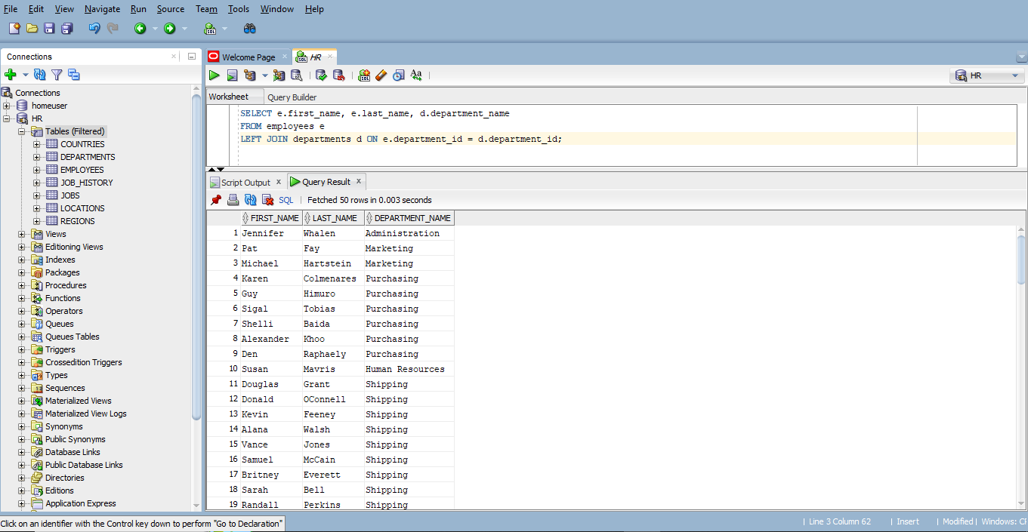

- Retrieve the first_name, last_name, and department_name of all employees, including departments that have no employees, using a RIGHT JOIN between the employees and departments tables.(hint : use right join).
